PORTING INTERFACE
SUBMITTING LSR

- Click New LSR.
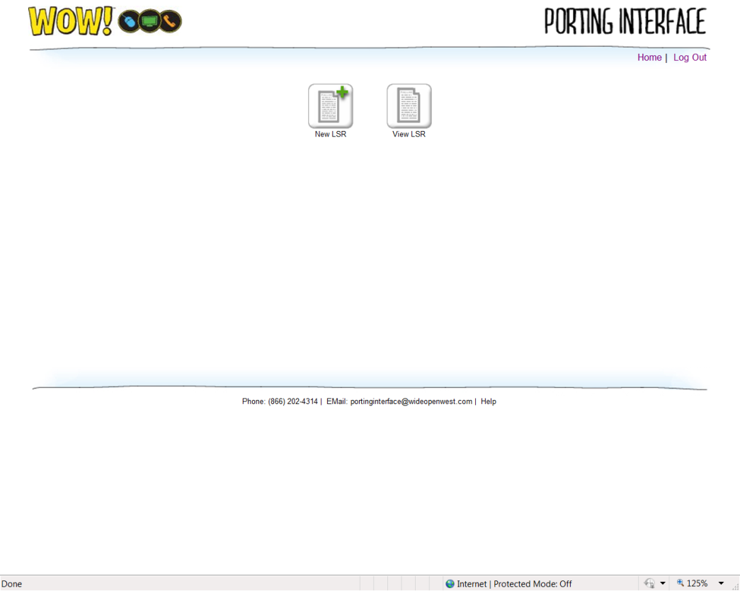

- Enter the required information. Fields marked with a red asterisk (*) are required.
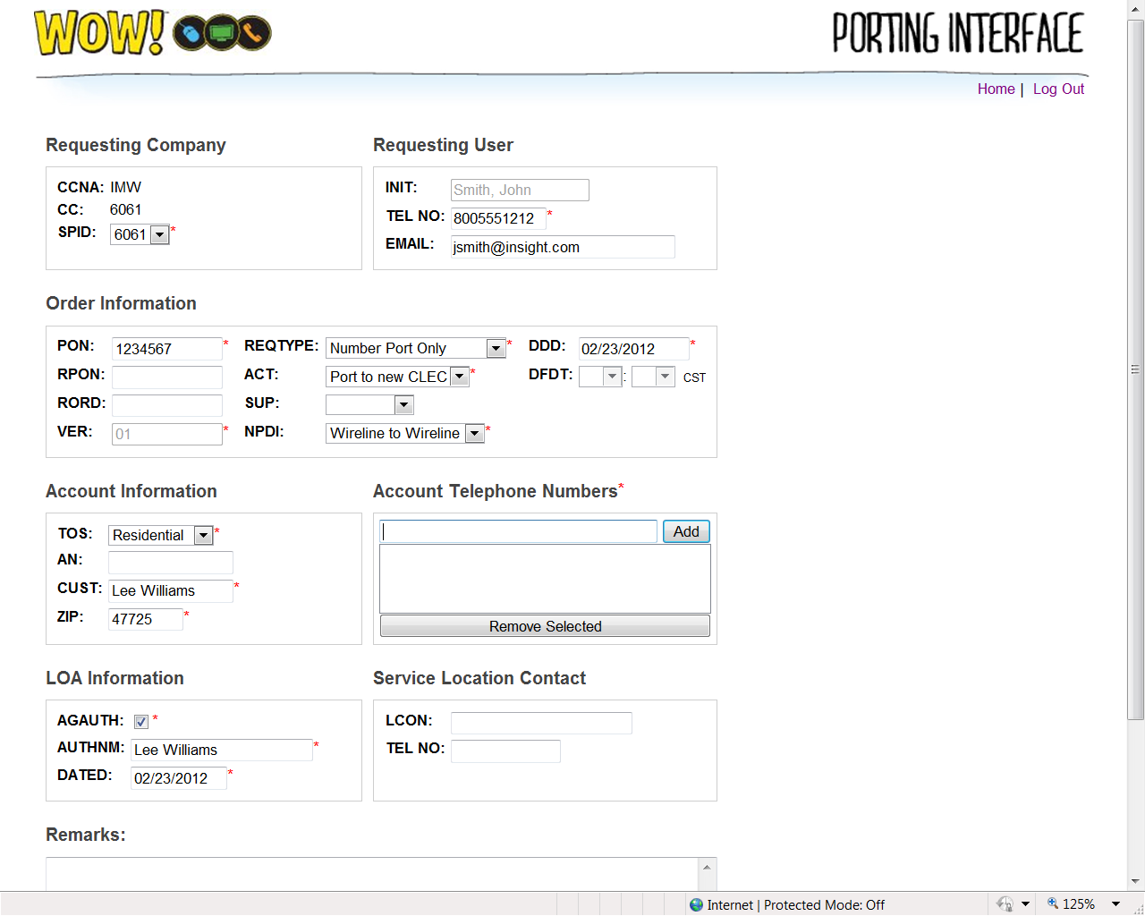

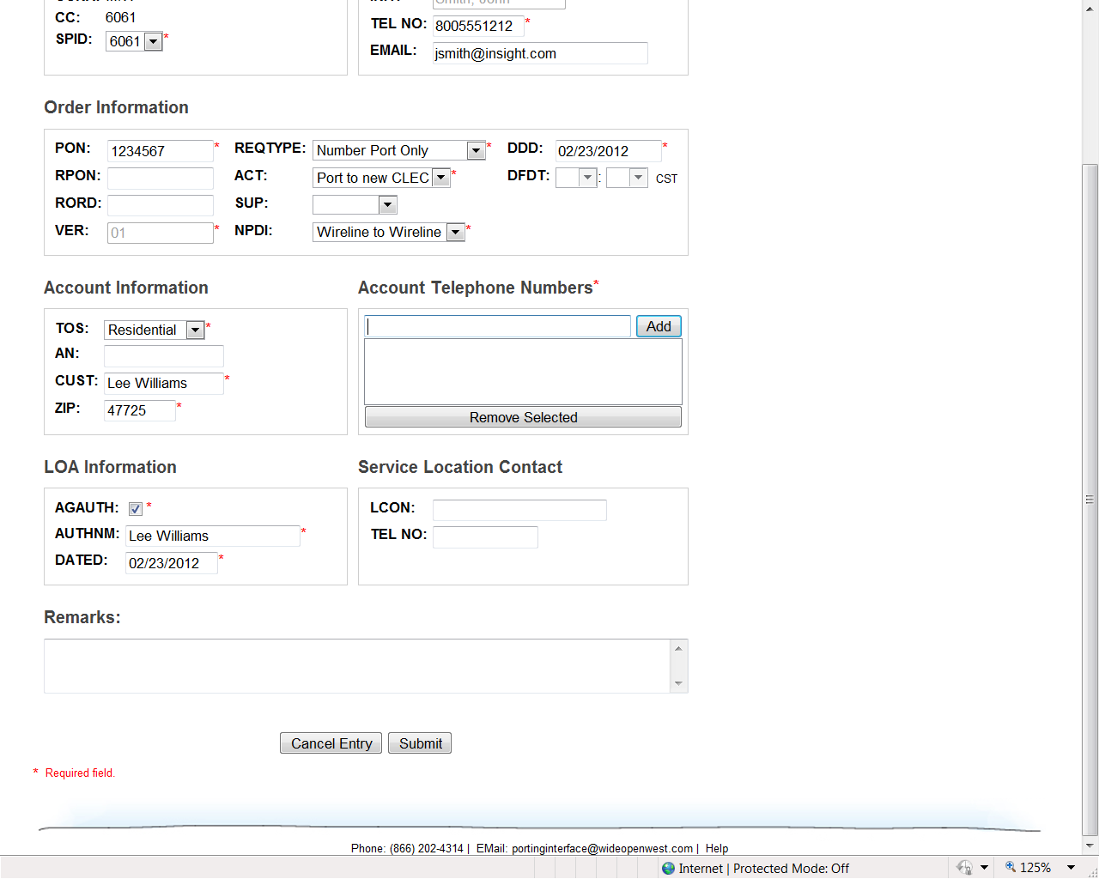

- Click submit.

- If there are errors, you will be directed to the fields that must be corrected. Make all necessary changes, then click Submit.
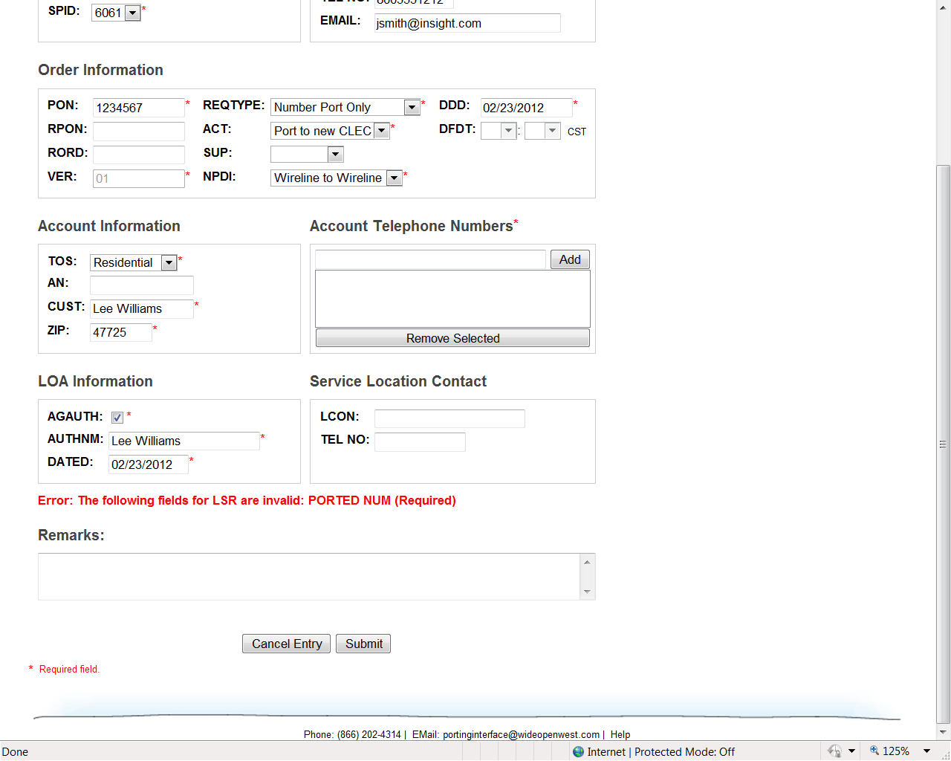
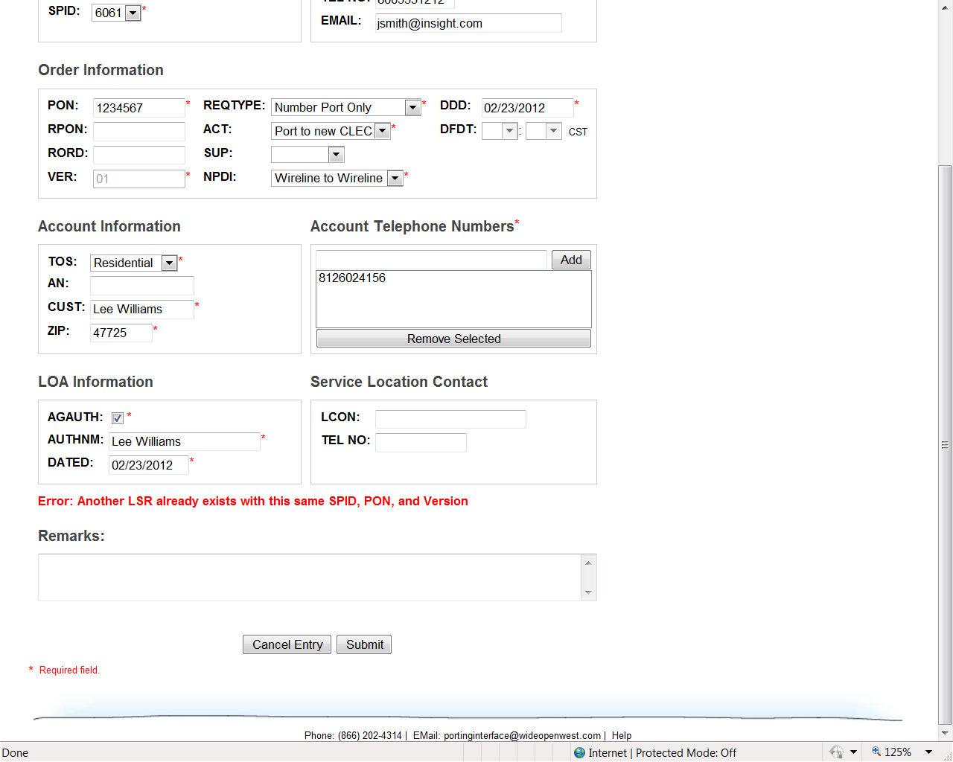

- If there are no errors, you will get a blank form that says “New LSR Saved”.
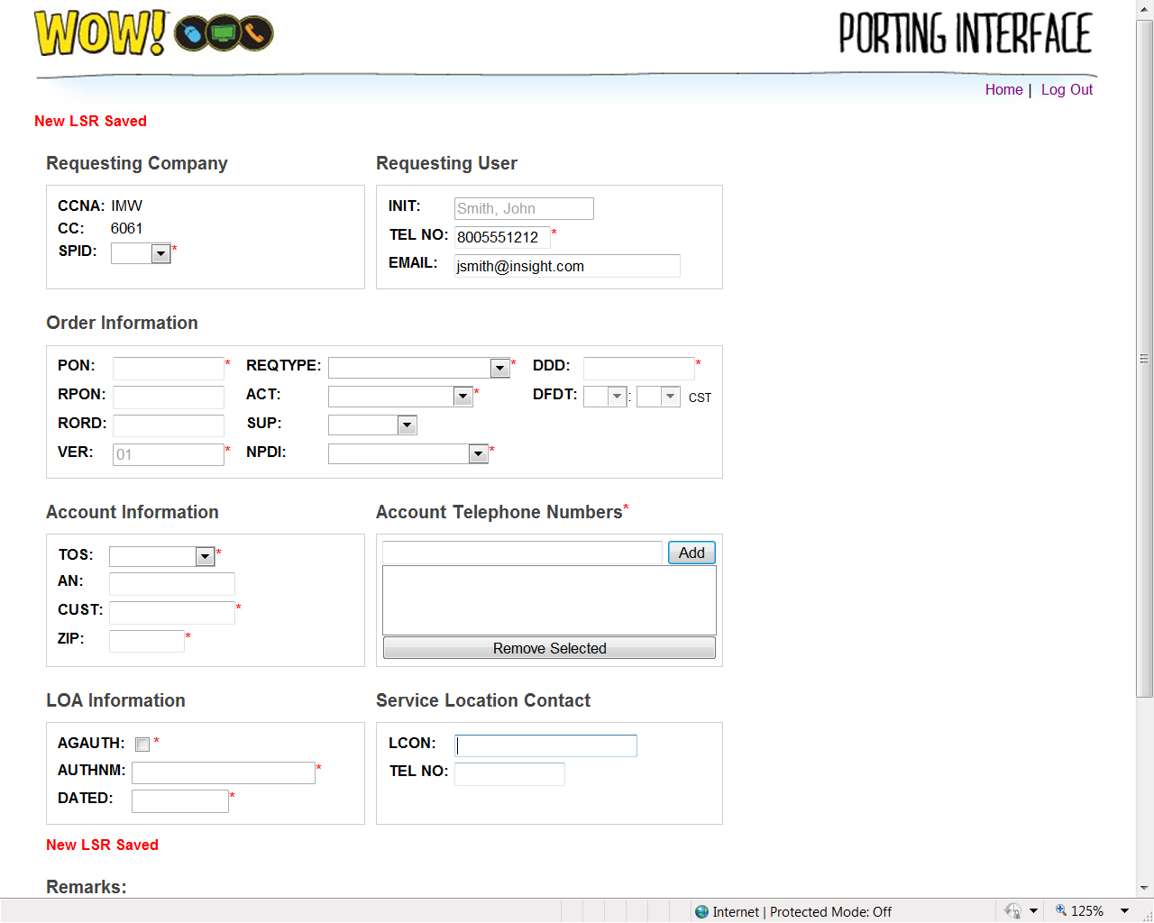

- All orders are worked within 4 hours.

