PORTING INTERFACE

MODIFYING USER PROFILES OR RESETTING PASSWORDS

Only your Company’s Administrator can modify user profiles or reset a password.

To modify user profiles or reset a password, complete the following steps:

- From the Home Page, click on Users.

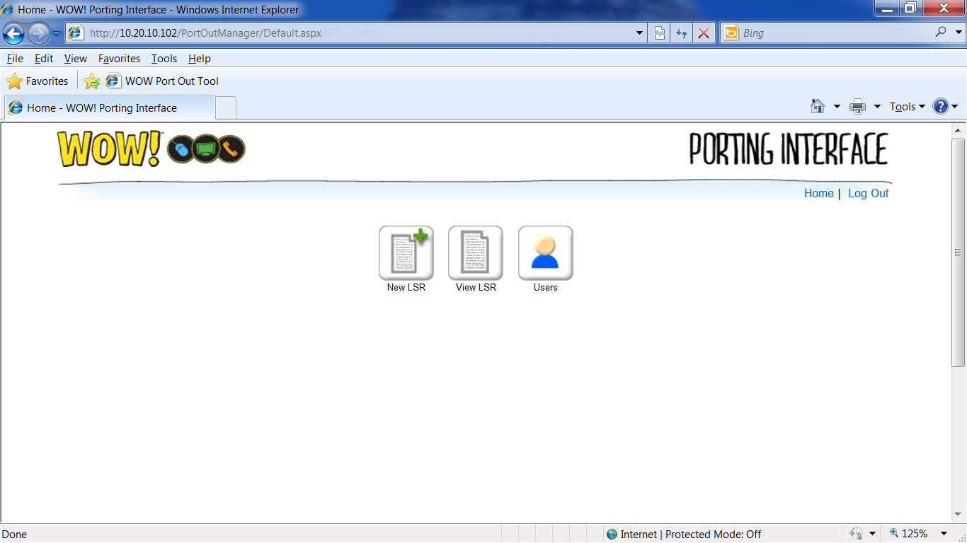
- On the User Management Home Page, click the User Name.

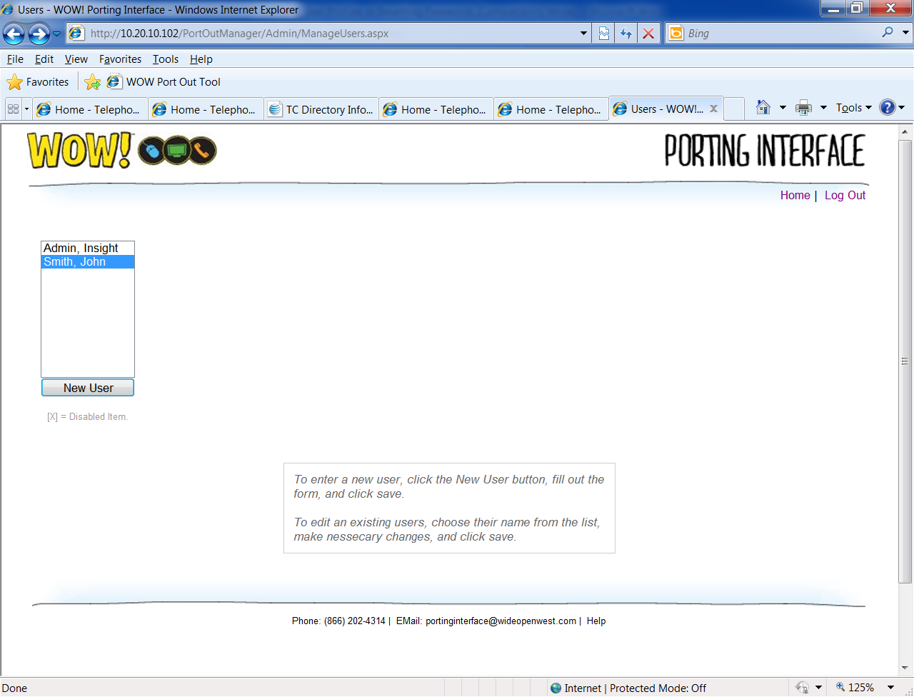
- From the Profile Page, you can make any changes or click the Reset link to Reset a Password. Once changes are complete, click Save.
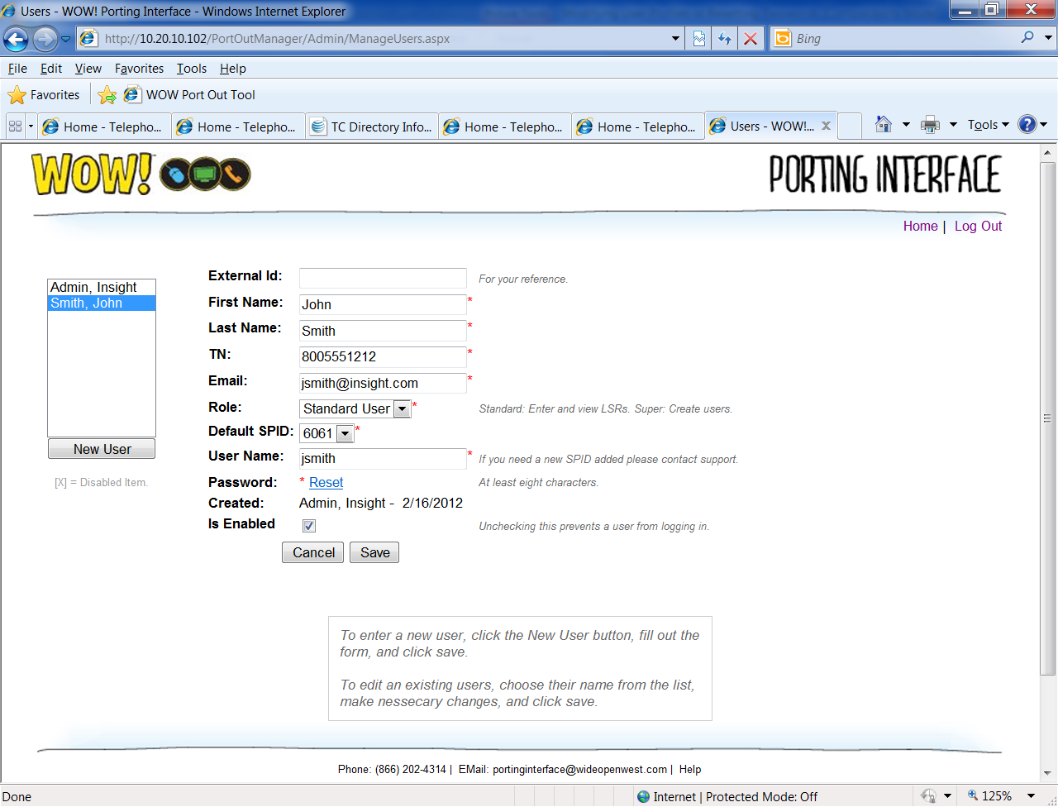

The password may be any combination of alphanumeric characters and must be a minimum of 8 characters.

