PORTING INTERFACE
CHECKING LSR STATUS

- Click on View LSR.
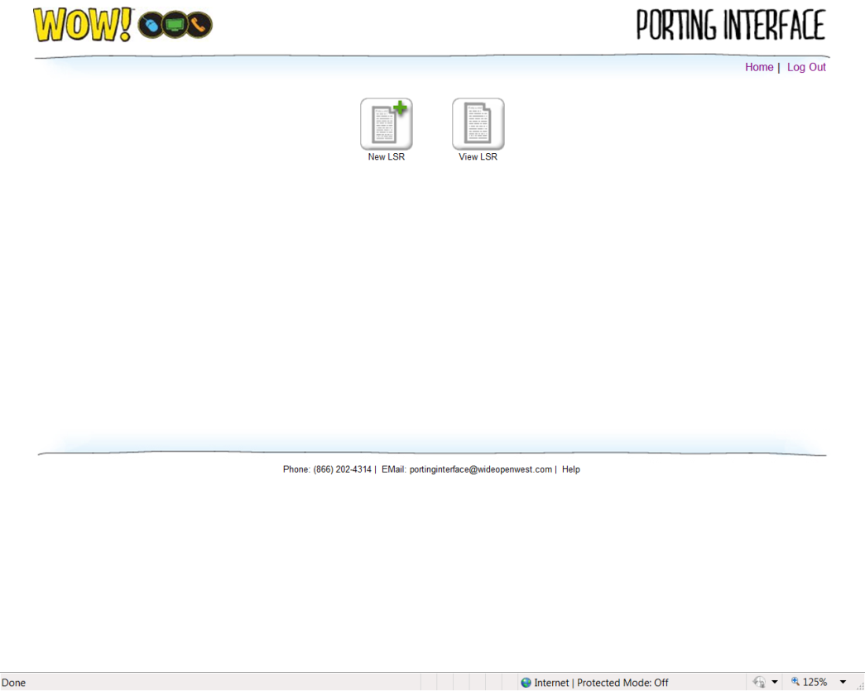

- Select the method you would like to search by (IE: PON, TN , etc), enter the appropriate Value and Click Search.
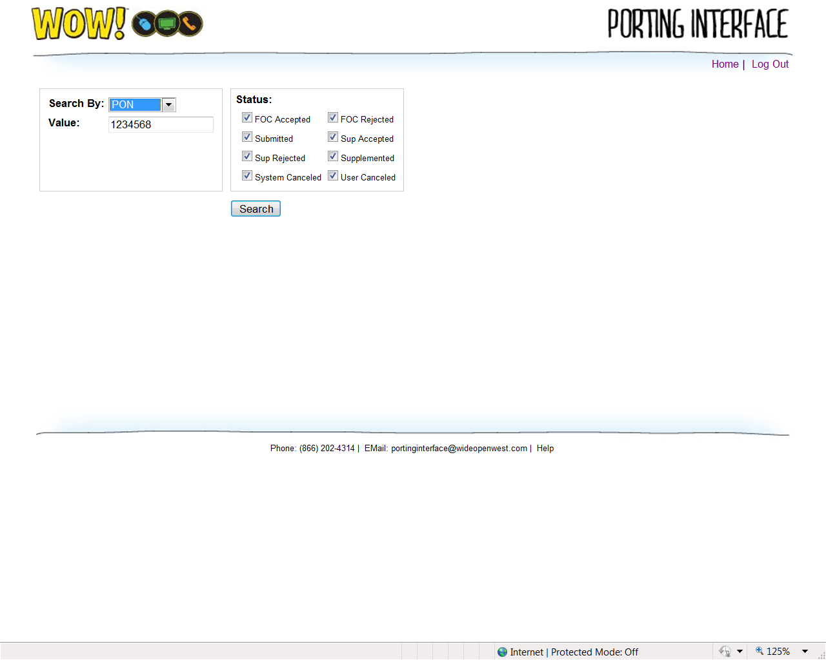

- The search results will come up with the status showing.
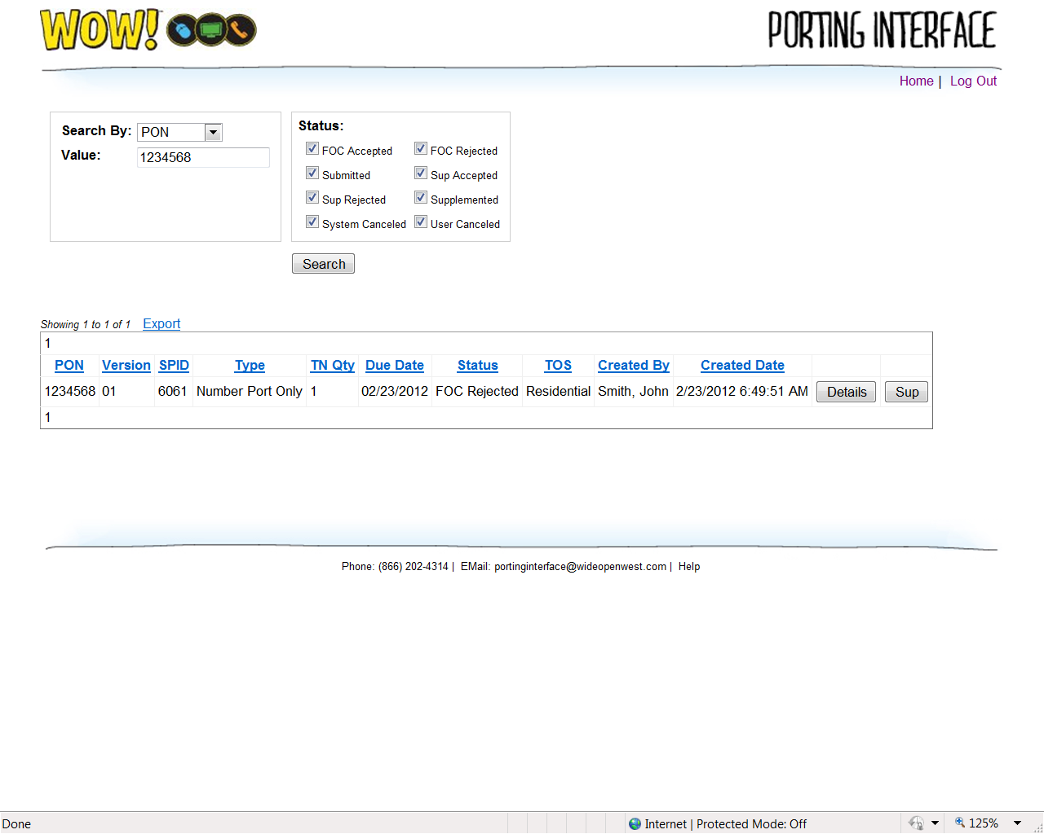

- If the Order was rejected, click the Details button to view the Reject reason.

- The Reject reason will be listed in the Remarks field.
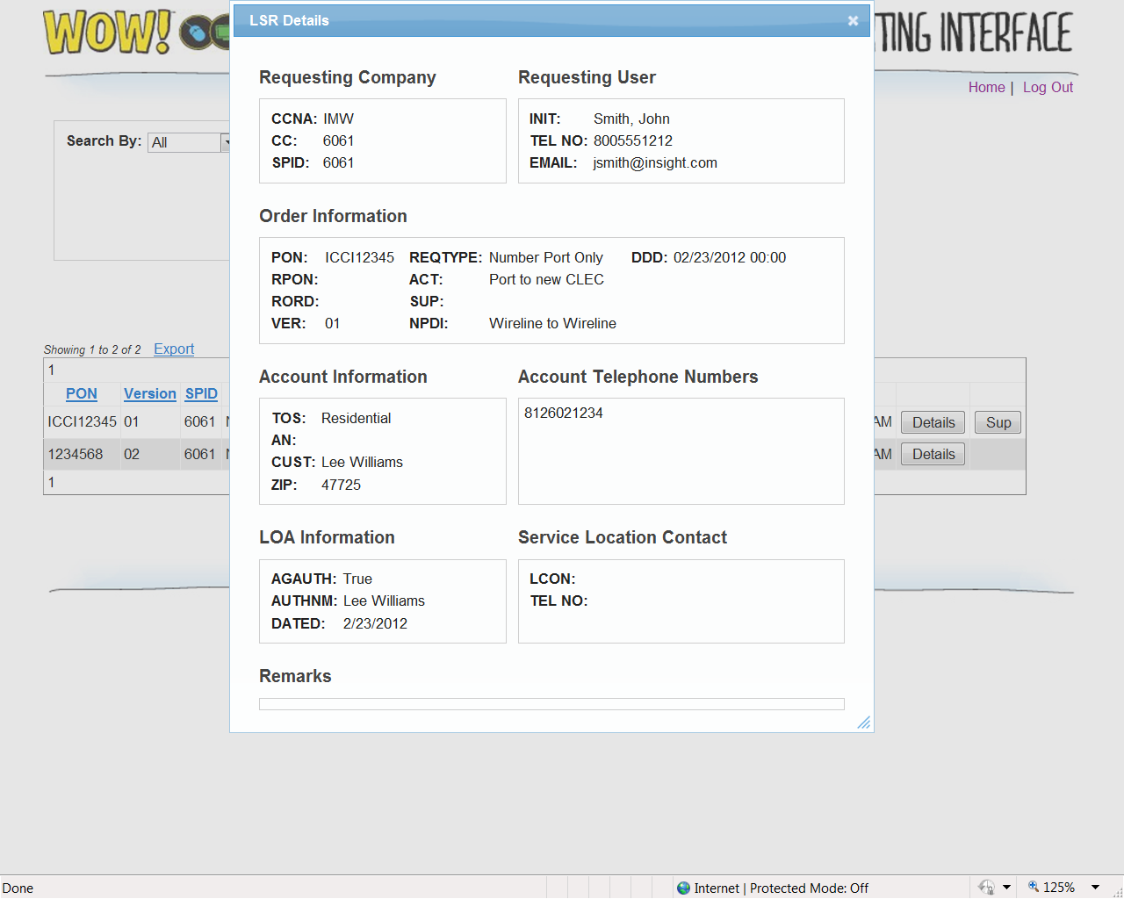

- Close the LSR Details window and click the Sup button to make corrections and Supplement the Order.

- Select the Sup Type and make any corrections. Enter any corrections that were made in the Remarks field.
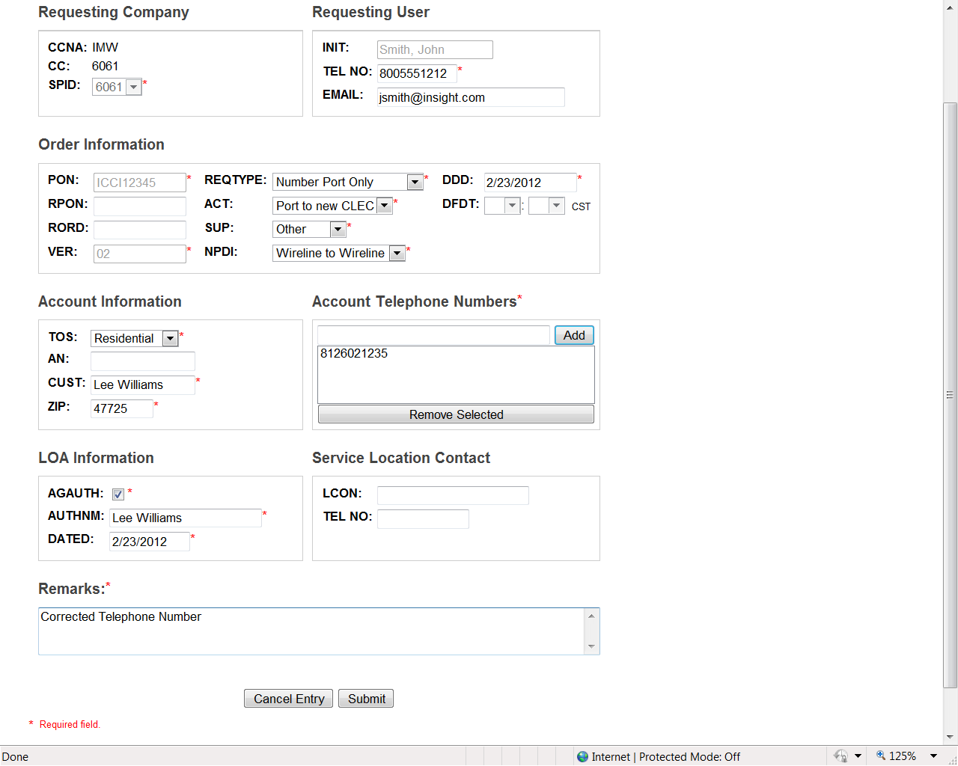

- If there are no errors, you will get a blank form that says “New LSR Saved”.
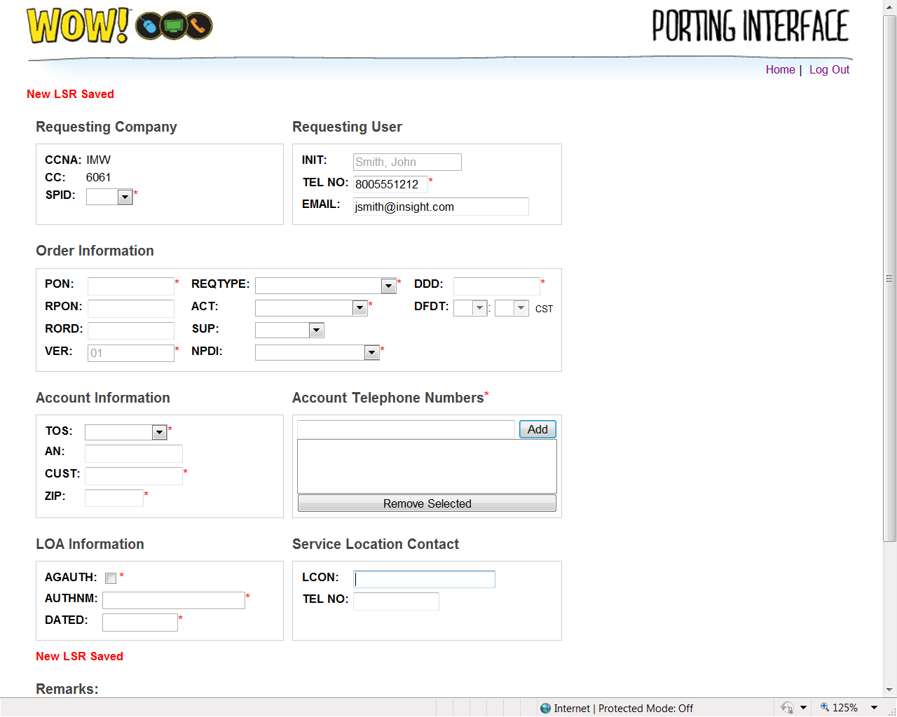

- All orders are worked within 4 hours.

