PORTING INTERFACE
ADDING NEW USERS

Only your Company’s Administrator can add new users.

To Add a User, complete the following steps:

- From the Home Page, click on Users.

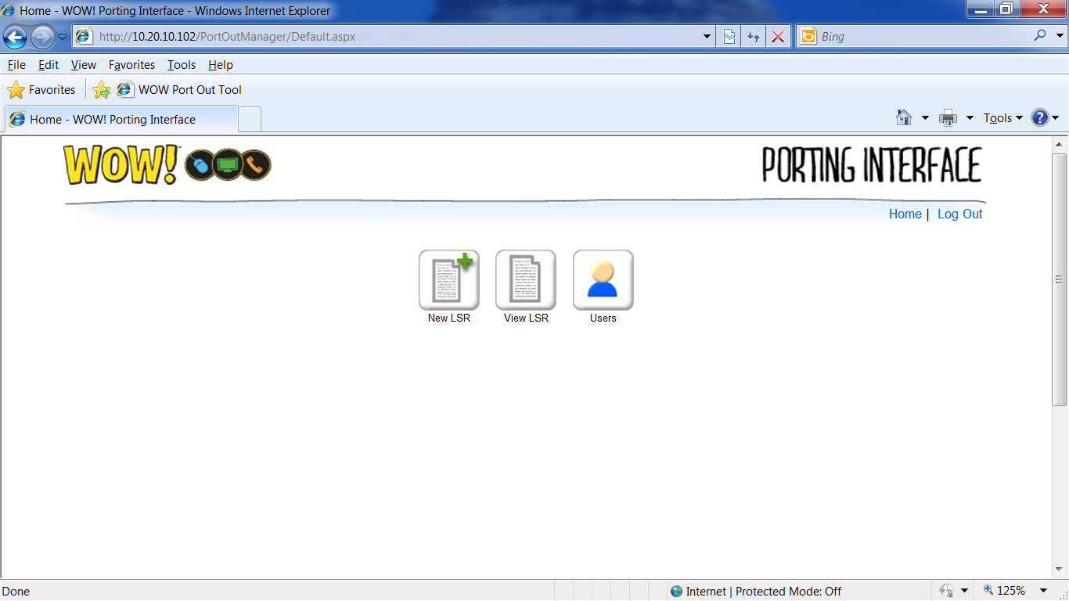
- Click New User.

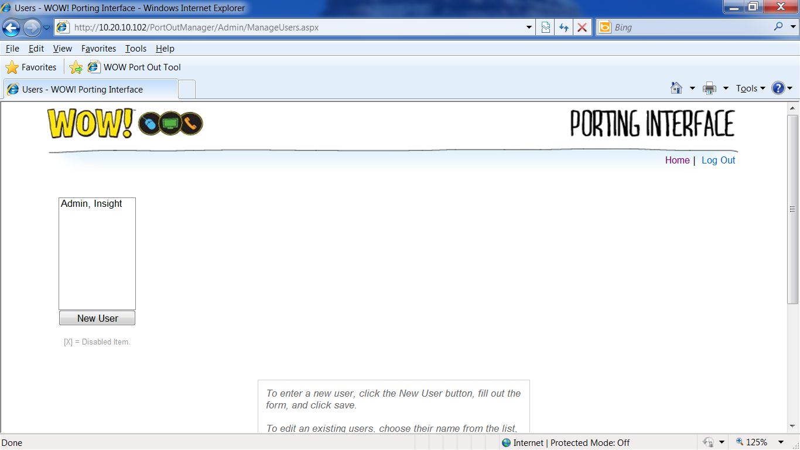
- Populate all mandatory fields and then click Add.

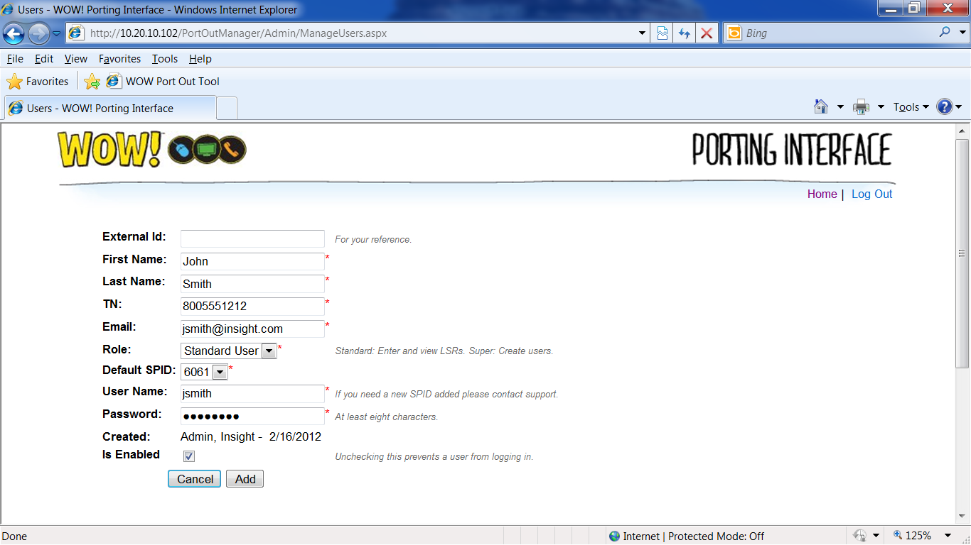

The password may be any combination of alphanumeric characters and must be a minimum of 8 characters.

Your new User will be able to login and create LSR Orders immediately.

To Disable a User, remove the check mark from the Is Enabled field.

